

USMAN INSTITUTE OF TECHNOLOGY

Department of Computer Science

**CS311 Introduction to Database Systems**

**Fall 2019**

**Lab # 8**

**Objective:**

.

SHOAIB AHMED

**Name of Student:**

17B-033-SE

**A**

**Roll No: Section:**

29-Nov-2019

**Date of Experiment:**

06-DEC-2019

**Date Submitted:**

Marks Obtained/Remarks: _____________________________

Signature: __________________________________________

A **ConstructCo** database stores data for a consulting company that tracks all charges to projects. The charges are based on the hours each employee works on each project. The structure and contents of the ConstructCo database are shown below.

|  |  |
| --- | --- |
| Table Name | Table Name |
| **Employee**  EMP_NUM NUMBER EMP_NAME VARCHAR2 EMP_FNAME VARCHAR2 EMP_INITIAL VARCHAR2(1) EMP_HIREDATE DATE DATE JOB_CODE NUMBER EMP_YEAR NUMBER | **Assignment**  ASSIGN_NUM NUMBER ASSIGN_DATE DATE PRO_NUM NUMBER EMP_NUM NUMBER ASSIGN_JOB NUMBER ASSIGN_CHG_HR NUMBER ASSIGN_HOURS NUMBER ASSIGN_CHARGE NUMBER |
| **Job**  JOB_CODE NUMBER JOB_DESCRIPTION VARCHAR2 JOB_ CHG_HR NUMBER JOB_LAST-UPDATE DATE | **Project**  PROJ_NUM NUMBER PROJ_NAME VARCHAR2 PROJ_VALUE NUMBER  PROJ_BALANCE NUMBER EMP_NUM NUMBER |

1. Write the SQL Code that will create the table of above structure (table name should be like TABLENAME_17B-XXX-CE)
2. Perform INSERT Command in the above tables of database **ConstructCo** (please find the data on page 3-4)
3. Write the SQL code to calculate the ASSIGN_CHARGE values in the ASSIGNMENT table in the ConstructCo database. Note that ASSIGN_CHARGE is a derived attribute that is calculated by multiplying ASSIGN_CHG_HR by ASSIGN_HOURS.
4. Using the EMPLOYEE, JOB, and PROJECT tables in the ConstructCo database, write the SQL code that will produce the results shown as in below figure.

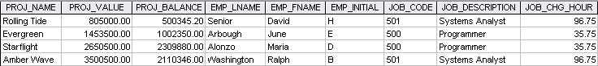

1. Write the SQL code that will produce result (FNAME, LNAME INITIAL, DESCRIPTION, CHG_HOUR, PROJ_NAME, PROJ_VALUE) with the list of all employee including those who do not have assign in any project.
2. Using the data in the ASSIGNMENT table, write the SQL code that will yield the total number of hours worked for each employee

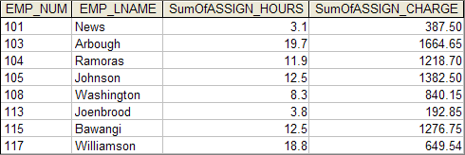

**Table :** Employee

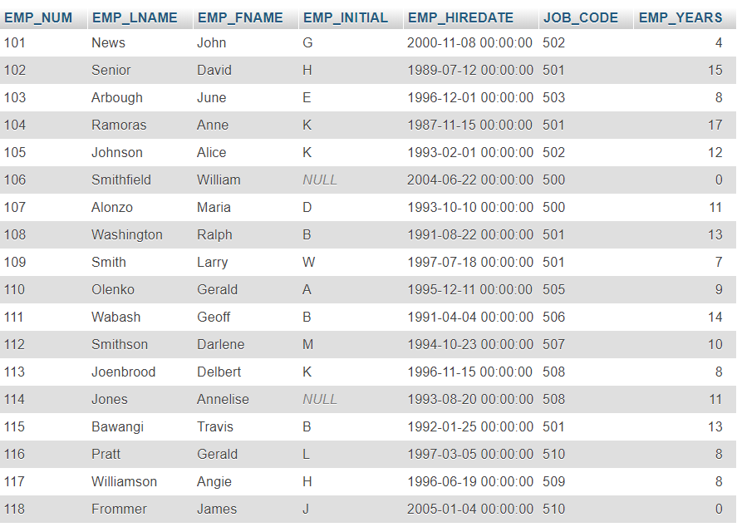

**Table :** JOB

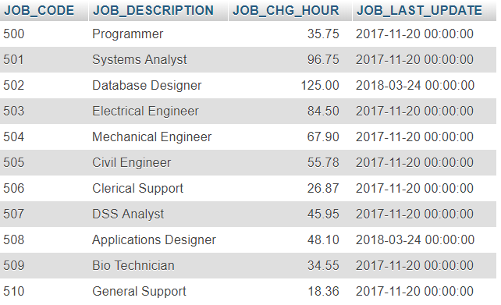

**Table :** PROJECT

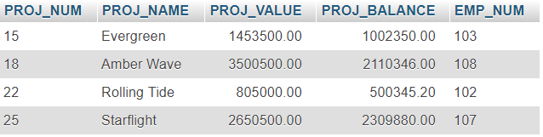

**Table :** Assignment

